Advancing Science and TEchnology thRough dIamond Quantum Sensing
ASTERIQS
Kick-off meeting
15 & 16 October 2018
École nationale supérieure de chimie de Paris

Objectives
- Present the ASTERIQS technical objectives and work plan- Enable partners to quickly ramp up project activities and work well together
- Discuss technical issues and agree on detailed WP roadmaps for the first period of the project
- Present the ASTERIQS organisation, project management and the dissemination activities; Understand common rules, methods, tools and processes

Preparation of the meeting for all participants
- Be familiar with the ASTERIQS Description of Action (DoA), in particular section 1.3.3 on WP descriptions
- Identify any specific issues that need to be discussed within your WP or at project level
- Prepare project and/or WP presentation prior to the meeting, using the templates provided by the project office

Agenda

Day 1 ● Monday 15 October 2018 ●
Time | Item | Speaker
12:30 | Registration
12:30 – 14:00 | Buffet Lunch
14:00 – 14:15 | Opening of the meeting  - Welcome & Introduction  - Objectives of the meeting  - Agenda, organisation and logistics | Thierry Debuisschert, THALES
14:15 – 14:45 | ASTERIQS Overview  - Project objectives  - Expected results  - Work structure  - Planning | Thierry Debuisschert, THALES
14:45 – 16:00 | Presentation of the Consortium (5’ each)  - Organisation profile  - Main contributions to the project/WPs  - Expectations from the project  - Team/key people | Each partner
16:00 – 16:20 | Coffee break
16:20 – 17:20 | Presentation of the Consortium (Cont’d.) | Each partner
17:20 – 17:50 | Project Management (WP9)  - Project Governance and project management organisation & TTB  - Administrative and financial management – Contractual documents  - Internal communication – Meetings | Nora Ouadi,  ARTTIC
17:50 – 18:00 | Wrap-up of Day 1 | Thierry Debuisschert, THALES
20h15 Social event (more details on page 6)

Day 2 ● Tuesday 16 October 2018●
Time | Item | Speaker
Presentation of the S/T work packages (45’ each)
- WP specific objectives and tasks – Focus on Year 1 activities
- Role and contributions of involved partners
- Interactions with other WPs / Expectations and needs
- Detailed planning for year 1 and expected results
- Milestones & Deliverables
- Identification of any issues/risks and mitigation plans
- Discussion: questions & answers
8:30 – 9:15 | WP1: Theory and protocols | Alex Retzker,  HUJI
9:15 – 10:00 | WP2: Materials | Christoph Nebel, FRAUNHOFER
10:00 - 10:45 | WP3: Engineering | Robert Roelver,  BOSCH
10:45 – 11:15 | Coffee Break
11:15 – 12:00 | WP4: Sensing devices based on established NV- centres technology | Milos Nesladek,  IMEC
12:00 – 12:45 | WP5: Developing new sensing functionality of diamond centres | Patrick Maletinsky, UNIBAS
12:45 – 14:00 | Lunch Break and visit of labs
14:00 – 14:45 | WP6: Bio-applications and healthcare | Fedor Jelezko,  UULM
14:45 – 15:30 | WP7: Exploring new scientific fields exploiting NV- technology | Vincent Jacques,  CNRS
15:30 – 16:15 | WP8: Dissemination, Collaboration, Exploitation | Thierry Debuisschert, THALES
16:15 – 16:45 | Coffee Break
16:45 – 17:15 | First General Assembly | GA Members
17:15 – 17:30 | Next meetings, wrap up, action list | Nora Ouadi,  ARTTIC
17:30 | End of the kick-off meeting

VENUE

Chimie ParisTech
École nationale supérieure de chimie de Paris
11, rue Pierre et Marie Curie, 75005 Paris
Meeting Room: Amphitheatre Friedel

Tel.: +33 (0)1 69 41 55 00
GPS position: 8°50'38.9"N 2°20'37.6"E
RER B: Luxembourg

Venue & Directions
Please note that the venue is situated in the center of Paris, just near the Pantheon and the RER Luxembourg.
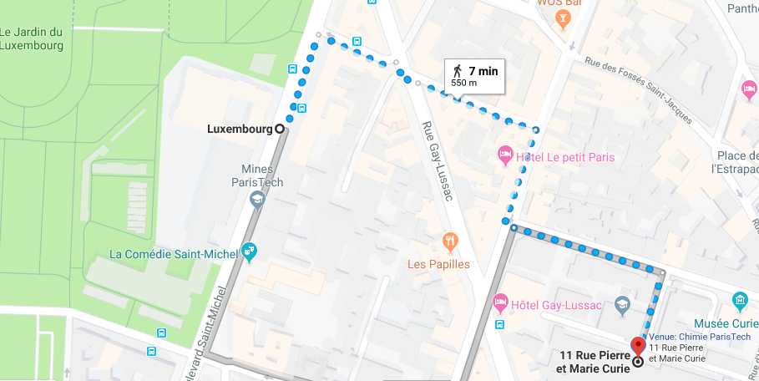

Hotels
A selection of hotels close to the venue, with indicative prices is listed below, together with the respective itinerary to the venue.
Hôtel André Latin  50, rue Gay-Lussac, 75005 Paris  Indicative price: 150€  Tel.: +33 (0)1 43 54 76 60  E-mail: hotel@hotelandrelatin.com  Web site | Hôtel des Grands Hommes  17, Place du Panthéon, 75005 Paris  Indicative price : 180€  Tel: +33 (0)1 46 34 19 60  E-mail: reservation@grandshommes.com  Web site
Hôtel Kyriad  5 Rue Véronèse, 75013 Paris  Indicative price: 130€  Tel.: +33 (0)1 47 07 20 90  E-mail: kyriadparisgobelins@wanadoo.fr  Web site | Hôtel Coypel  142 Boulevard de l'Hôpital, 75013 Paris  Indicative price: 130€  Tel.: +33 (0)1 43 31 18 08  E-mail: N/A  Web site
How to get from the proposed hotels to the venue
From the “Hotel des Grands Hommes” to the venue:
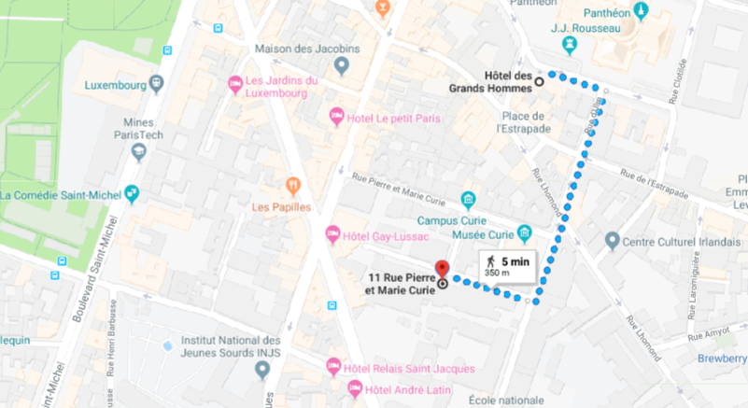

From the “Hôtel André Latin” to the venue:
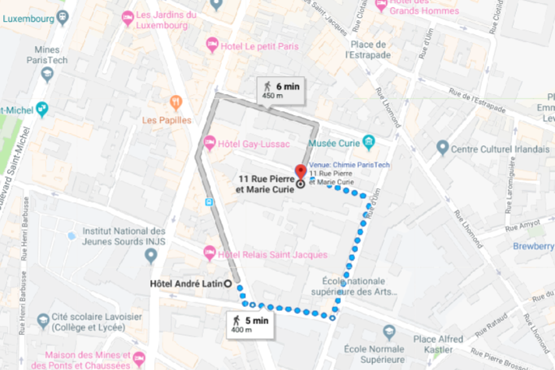

From the Kyriad and Coypel hotels:
Please note that these two hotels are located near the venue, in the “Place d’Italie” quarters:
- Take metro 7 at “Place d’Italie”, direction “La Courneuve »
- Get off the metro at “Place Monge” and walk to the Venue (see map below)

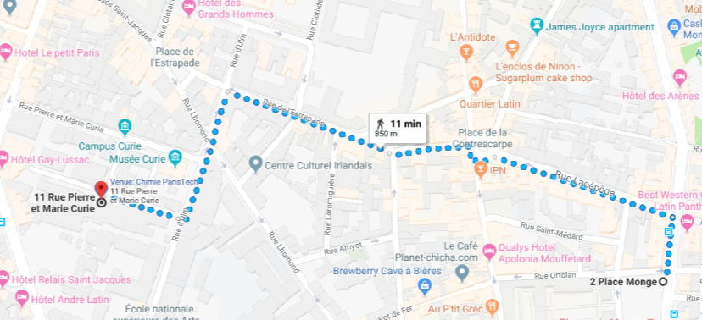

SOCIAL Event
Parisian Diner cruise, on board « Le Capitaine Fracasse »
Boarding 20h15 |Departure: 20h45 |Return: 23h
Check cruise route and boarding access on: https://www.lecapitainefracasse.com/en/
How to get to the boarding access
- Take RER B from Luxembourg to Denfert-Rochereau station
- Take metro 6, direction Charles de Gaulle-Etoile and get off at « Bir-Hakeim” station (see “Metro station on the map)
- Walk through the Bir-Hakeim bridge until the middle of the bridge and take the stairs to “l’Ile aux Cygnes” (see the yellow line on the map) and reach the “Boarding access.
